Intro to Public Records: Realist User Guide

Property Intelligence Built for Agents Building Businesses
Overview
Whether you’re helping existing clients or prospecting for new business, uncover valuable insights, view trends, and access analytics and risk reports that lead to informed decisions every time.
- Research all property parcels in South Carolina and Georgia.
- View owner information, property characteristics, FEMA data, valuation trends, deeds, public record filings, demographics, search for comps, and more.
- Develop focused farming/marketing lists and create mailing labels.

How to access Realist
- From the REsides dashboard
- From the Matrix menu bar
- From the Tax tab on the Matrix Listing 360 Property View.
- By clicking on the Tax Map # hyperlink on the Matrix Listing 360 Property View

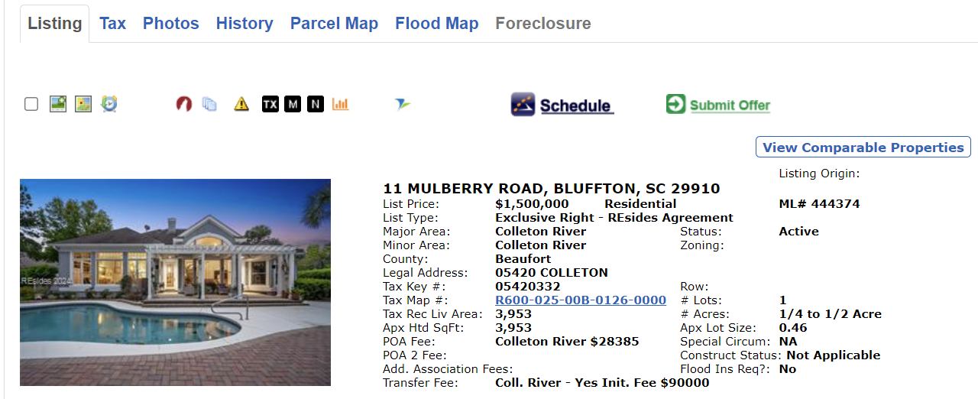
- Realist Icons at the top of a listing
Realist can be accessed on any device and is mobile-friendly.

Accessing Realist Reports from a Listing
The Realist TX icon and the Property Map # hyperlink launch the Property Detail report, a property summary. The report can’t be modified and contains basic property information.

The Realist M icon launches the Realist Database, and the Realist N icon launches the Realist Neighborhood Profile.

Property Detail Report Tabs Description

Property Details

Property description: beds, baths, list or sale price, list or sale date, sq. ft., lot sq. ft., year built, property type

Owner Information: name(s), billing address

Community Insights: median home value, crime risk score, school standardized test rank, lifestyle report, and home value forecasting

Location Information: subdivision, area name, area code, census tract, carrier route, LEGRES (legal residence exemption, flood zone code, flood zone panel, flood zone date

Tax Information: click the Tax ID hyperlink to access the county Property Appraiser’s site, legal description, lot number

Assessment and Tax: Assessment values and tax amounts for the past three years.

Characteristics: land use, lot acres, lot area, living area, total sq. ft., stories, beds, baths, porch, porch area, patio/deck area, garage sq. ft., year built, effective year built (defined as the first year when a home was assessed with its current components. This is typically used when a home undergoes major additions), parking type, number of buildings

Sell Score Indicator: this indicator is based on the CoreLogic Propensity to List Model. It features a numerical value (0-1000) that predicts the relative likelihood a property will be listed for sale in the next six months.
- Estimated Value – RealAVM™ (Realist automated valuation model; this is derived value and should not be used instead of an appraisal), RealAVM™ range, confidence score (a measure of the extent to which sales data, property information, and comparable sales support the property valuation analysis process. The confidence score range is 50 – 100), forecast standard deviation (denotes confidence in an AVM estimate and uses a consistent scale and meaning to generate a standardized confidence metric)
- Rental Trends: a CoreLogic® derived value and should be used for information purposes only
- Listing Information: data pulled from the current MLS listing (if applicable) and historic MLS listings.
- Last Market Sale & Sale History
- Mortgage History: shows the history of financing obtained for this property
- Property Map: property location and lot dimensions
- Foreclosure History: only display if applicable to the property

Action Buttons

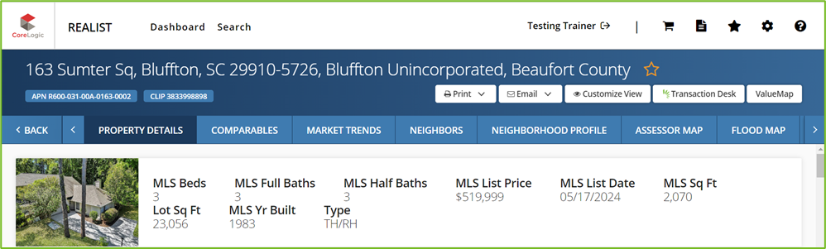

- Print: click the arrow to select Quick or Custom print (select the reports to include)

- Email: click the arrow to select Quick Custom email (select the reports to include in the email)

- Customize View: Remove any section you do not wish to display

Note: if you remove a section, it will not be displayed the next time you view the report, but you may re-add it.

- Transaction Desk: launches the Create a Transaction screen in Transaction Desk

- ValueMap: See the home's estimated value and Determine the estimated value of adjacent homes.
- adjust home facts and re-calculate a home’s value. It is helpful when changing a CMA for values when bedrooms, bathrooms, square footage, etc., do not match the subject property
- View nearby recently sold properties

Comparables
- Build a mini CMA in Realist, pulling comparable sales from tax records and MLS sales.
Note: Realist gets its information from public records, so it does not update in real time. The most recently sold properties may not be displayed in Realist. Be sure to check the date Realist was last updated for the county where the subject property is located.
- View a map of comps, a summary statistics section, and a grid showing comparable sales. Sales with a corresponding MLS listing have a red teardrop icon associated with them. Listings that are sold outside the MLS do not have this icon.
- The Customize View button lets you remove any section of the report you do not wish to display.
- Click the Search Criteria button to modify the criteria for comparison. Then, you may edit the filters (distance from the subject, sold date range, bedrooms, bathrooms, pool, search period, etc.). To use these modified criteria only for this report, click Submit. To make these your new default criteria for pulling comps in the future, click Save and Submit.
- After modifying the criteria, return to the results grid to de-select any properties you do not want to include. Then click Generate Report.
- Once the report is generated, you may modify it by clicking the Customize View option. Following the instructions above, you can also print or email the report.

Market Trends
The Market Trends tab displays several gauges and graphs with statistics for various Zip Code, City, or County trends. Some of these include Closed Sales, Median Sale Price (Tax and MLS), Active Listings, Median Days to Contract, Median Price per Square Foot (Tax and MLS), Number of Sales (Tax and MLS), and Change in Sales Activity (Tax and MLS). Please verify the last time this information was updated in the Realist reports.

Neighbors
The neighbor's tab shows the information on nearby (neighboring) properties. To modify the search criteria:
- Click Modify, then Search at the bottom right of the screen
- You may select a maximum of 10 neighboring properties, a maximum distance from the subject, and a geographic boundary such as the same subdivision or same street.

Neighborhood Profile
This tab includes demographic information for the zip code from the US Census Bureau, nearby schools, and nearby businesses. “Customize View’ will allow you to remove sections of the report if you wish. “Search Criteria” will enable you to set preferences for businesses, distance from the subject, and school categories for the report. You can print and email these reports following the instructions above.
- Demographics: Demographic information comes from the US Census Bureau and is reported for the zip code of the subject property. Remember that the Census is taken once every ten years. The last was in 2020, and the next was in 2030. While valuable information is in the Demographics section, agents should be careful to comply with the Fair Housing Act and not "steer" buyers to specific neighborhoods based on protected classifications.
- School Information: The school information is for the nearest schools, not necessarily the zoned schools for this property. Information includes School Name, Distance, Grades Served, Number of Students, Students per Teacher Ratio, and SchoolDigger.com rating. The SchoolDigger.com Rating is based on standardized test scores on a scale of 1 to 5. Some schools also have a Community Rating, which is based on satisfaction survey results from stakeholders. Under the modify/search menu option on the bottom right side of the screen, school criteria can be modified, including distance from the subject,

Public versus private, and school category (Elementary, Middle, High, College, etc.).
- Local Businesses: Several local business categories (recreation, dining, organizations, etc.) are available. To set preferences, go to the “Search Criteria.” Scroll down to the Business section. You can set the maximum distance from the subject, the maximum number of businesses per category, and the desired number of business categories.

Foreclosure
This tab appears only for distressed properties. It links to the Lis Pendens, Final Judgement, or any other pre-foreclosure or foreclosure document.

Flood Map
This brings up a static flood map along with information on the property's flood zone. Note the key under the map. Some properties are completely in or out of a flood zone, while others are partially in a flood zone.
Note: Once you progress through all the tabs, click the “Back” button at the top and return to the original view.

Searching Directly in Realist

Realist Home Page

- The Star icon is where you’ll find your saved properties
- The Gear icon will take you to settings, where you can select your preferences.
- The Question Mark icon contains a Realist User Guide

View Results displays the number of matches, up to a maximum of 10,000. Realist displays results for up to 3,000 records in sections of 1,000 at a time.
Results will be displayed on the map and are color-coded.
- Green: Active listings
- Red: Sold listings
- Yellow: Pending sales
- Purple: Expired listings
- Black: No associated listing activity on the property record

The map tools are at the top left of the map. Hovering over the symbols displays the map feature you can use.

On the top right of the map, you will see the options to display your results in a “split” view—map on top/results on bottom, “map” view only, or “list” view, which will display the results.

At the top of the Search forms on the left, you can select or change your preferred counties. You may select up to 8 counties and may change them as needed. When a county is selected, it indicates the last time the public records were updated.

Thus far, we explored the Realist Reports that can be accessed from a listing in Matrix. However, as Realist is a state-wide public records database, searching for properties directly in Realist is also possible. On the home page of Realist, you will see a search form with two tabs: Quick Search and My Search.

Quick Search
The Quick Search is essential and is meant to pull individual (or small numbers of) specific properties. You can search by address, owner name(s), MLS number(s), or PID(s). To add multiple names or numbers, use the (+) button.

My Search
Includes search form templates created from the system, and everyone can create and save their own. Anyone who has used Realist in the past and saved search forms will also see them here in this new version. You can also create up to 25 of your own saved search forms. There are two types of saved searches: saved search form only and saved search form with values. Saved search forms will remember the fields to be searched but retain no search criteria. The saved search form with values will remember the fields and values within those fields to be searched.

My Search may also offer several default search forms, such as
- MLS Search: Search by frequently used Listing information, such as Listing Number, Listing Status, List Price, and many other options.
- Foreclosure Search: Locate distressed properties, such as Pre-Foreclosure, Auction, or bank-owned/REO, for potential customers or to find properties for investors.
- Tax Search: Search public records for any South Carolina or Georgia property.

Attributes (Additional fields of criteria)
In Realist, fields in the My Search pane are called search attributes and can be edited by clicking “Customize Search.” Search attributes can also include the areas of a Map you search within. Since you can edit and save the attributes in your Searches and Forms, you can customize My Search for your personal use.

NOTE: If you are going to add attributes to your search, do so before you begin entering criteria. Otherwise, you will lose the criteria you entered when you go to “Customize Search.”

Adding Criteria (Attributes) to Searches
The pre-set system search forms in Realist currently do not allow the option to select a specific property type. If you perform a search, you will get all property types unless you customize and save a search form that includes this attribute. The procedure below would be followed for any attribute (criteria field) you wish to add to create custom searches.
- Select the search form you wish to customize (i.e., Tax Search)
- Click “Customize Search” at the top of the column
- Select the attributes you wish to add to your search from the list
Tip: The attribute for all the different property types is called “Land Use – CoreLogic.”
- You may now name and save it or click “Apply” to use the criteria for a single search. You will still have the option to save the search from the “My Search” tab if you wish.
- Searches may be saved with blank fields, or you may save them with “values,” which are specific criteria you use frequently. You may have up to 25 saved searches.

SEARCH RESULTS

Table View
When search results are returned initially, all results on the list are selected, and if you are viewing the Realist Map, all the properties will be displayed on the Map. The selected items will also be used if you choose to export, email, or print the search results. The Search Results Table displays columns of data for each property record your search returned. You can show more or less information using the Customize Table menu. It would be best if you took note of any columns you remove since there is no option to return the results display to a default view.

NOTE: You can select up to 30 columns to display; however, the more columns you select to appear, the more scrolling will be required to view the information.

You can sort your search results by clicking on any column headers. Clicking once on any column will sort the results in descending order. Clicking twice will sort the results in ascending order. Once a particular column has been sorted, the Table header will appear with the arrow highlighted in blue.

CARD VIEW
Card view lets you view the search results in a “card” layout. To view the search results in the “card” layout, run a property search and click the “card” option on the grid to switch the view.

When viewing search results in the card view option, fixed and customizable attributes allow you to customize the most relevant attributes to display on the results cards.

Fixed Attributes (cannot be changed) are the following:
- MLS Photo
- MLS Status Indicator
- MLS Sales Price
- Site Address
- Beds
- Baths
- Building Sq. Ft.
Customizable Attributes: You can customize up to three attributes in card view. Click on “Customize Cards,” select what you want, and click “Apply” to save your selection.

SAVED PROPERTIES
With Saved Properties, you can select, while in card view, to add properties to a list for easy access later. Click the “star” on the property card and the property will be added to your saved properties using the “star” icon at the top of the page. You may add up to 50 saved properties.

To remove a property from your Saved Properties, open the property card and uncheck the property in the top left corner of the property card.

Tax Search
This form contains fields from the county property appraisers' and public record sites. It is excellent for developing targeted lists of properties and owners meeting specific characteristics.
Example 1: Larger Homes in a specific subdivision owner occupied for 20+ years
In this example, you want to send a highly targeted mailing to a subdivision. Let's pretend you want to mail to the property owners of a subdivision in a specific zip code, but you only want to send it to particular owners. You want to get listings of property owners who have owned them for over 20 years and have larger homes (3000 sq. ft. or more). These owners may be ready to downsize.
- Go to the Tax Search form.
- If you have not created a search that includes the ability to search for specific property types, go to “Customize Search” and select and apply the attribute for “Land Use – CoreLogic.” This will allow you to choose the property type you wish to search for.
- Ensure the correct county is selected.
- Select the appropriate subdivision. (Hint: You may also want to include the zip code in case multiple subdivisions with that name exist in your selected counties.)
Optional: Select "Yes" under the Owner Occupied field.
- For the “Living Sq Ft” field, click on the "is between" link and change it to "is greater than.” Then enter 3000.
- For the “Last Mkt Sale” field, click on the "is between" link and change it to "is less than.” Then enter 1/1/2000.
- Click the Search button to run your search.
- Click “Labels” to create mailing labels or “Export” to export the list into a CSV file.

Example 2: All owners residing in a local zip code with residency in my home state
In this scenario, an agent who grew up in Ohio and now lives in a particular city wants to send a mailing to all subdivision property owners who reside in Ohio (per the Tax Mailing Address).
- Go to the Tax Search form or your saved search, including “Land Use-CoreLogic.” If you want to include all property types, you will not need this field.
- Under Property City, enter Your city. You may also use a Zip Code or Subdivision.
- Under Mailing State, select Ohio. (Mailing State is where the Tax bill goes.)
- Click the "Search" button to run your results.
- Click "Labels" or "Export.”
Example 3: All properties in a city with a specific use code
For this example, a commercial real estate agent wants to find all the Hotel/Motel owners in Hilton Head Island, SC. This will require you to add a new field (Land Use – CoreLogic or Land Use - State) to the Tax Search form.
  - Go to the Tax Search form.
  - Click “Customize Search.”
  - Check box the Land Use field you wish to use and click “Apply.”
  - Once back in the search form, select Hotel or Motel.
  - Under Property City, enter "Hilton Head Island.”
  - Click the Search button.
  - Click the “Labels” or “Export” button.
Note: Adding a sale date range could be a method to find commercial comps.

MLS Search
The MLS search pulls up public property records for properties with corresponding MLS records. This is a great tool to find expired listings!
An agent wants to pursue all expired listings in a specific zip code (or your preferred area) from July 1, 2023.
- go to the MLS Search Form.
- Under the MLS Status field, select "Expired.”
- Under the MLS Expiration Date field, set the parameter to "is greater than" and enter 7/1/2023. (Click on the "Is Between" link to change to "Is Greater Than".)
- Under the Property Zip field, enter the desired zip code (your preferred area).
- Click the "Search" button.
- Scroll through the results to see if any have the green MLS icon, showing that the property has been relisted. De-select these properties.
- Click "Create Labels" or "Export" under the results menu.

Foreclosure Search
The Foreclosure Search form is a great tool for finding properties in pre-foreclosure (the owner is in default but has not been convicted yet), upcoming auctions, and bank-owned properties in a given area.

Example 1: Pre-foreclosures
Pre-foreclosures could be a great source of leads. These property owners defaulted, and the lender has filed a Lis Pendens. However, the owner still possesses the property and can still sell it.

- Go to the Foreclosure Search form. (If you only want single-family properties, you will need to go to “Customize View” and add the “Land Use – CoreLogic” attribute.)
- Under the Foreclosure Stage field, select "Pre-foreclosure.”
- Choose any other criteria, such as Owner Occupied, Last Mkt Sale, etc., to narrow down your search (if desired).
- Select a Subdivision or Zip Code.
- Click the "Search" button.
- Under the results grid, click “Labels” or “Export.”

Example 2: Upcoming Auctions
To search for properties in the Auction phase:
  - Go to the Foreclosure Search Form
  - Select "Auction" under the Foreclosure Stage field.
  - Go to the Auction Date field and set the date as "is greater than" today's date.
  - Enter geographic and other criteria.
  - Click "Search.”

Example 3: REOs
Agents may want to search for bank-owned properties in a subdivision or zip code for various reasons, such as finding REOs not yet listed or researching how many properties in a complex are bank-owned.

- Go to the Foreclosure Search Form. (If you want a specific property type, you will need to go to “Customize Search” and add the “Land Use – CoreLogic” attribute; otherwise, you will see all property types displayed in your results.
- Select "Bank Owned" under the Foreclosure Stage field.
- Enter geographic and other criteria.
- Click "Search.”


Realist Map

The Realist map contains several useful interactive tools. However, remember that Realist is a “set and forget” system. If you pin something to your map and do not remove it, it will remain there the next time you open Realist.

Drawing Tools: Draw a shape on the map and then add additional criteria (such as owner-occupied) to the search form. Click search to run results. (You must click search to get results, unlike in Matrix, where they automatically populate when criteria are entered). Note that in Realist, as ALL properties are pulled, once the map shape gets too big, the popup showing the area will turn red, indicating that you have too many results to display on the grid.
Boundaries: Add boundaries to the map, such as flood zones, zip codes, and zoned schools.
Property and Sales Information: Place pins on the map for distressed properties, recent sales, corresponding MLS listings, and property characteristics.
Trend Layers: See trends (aggregated by zip code) for statistics such as Median Sales price, Real AVM, and number or percentage of properties in foreclosure.
Points of Interest: Pin Food & Dining, Banking, Religious Organizations, and other local businesses.
Driving Directions: Get Driving Directions to a location on the map.
Locate on the Map: Center the map on a particular address. Measurement Tool: The tool for measuring distances. Annotation Tool: Allows you to write a note on the map.

Preferences
There is a Preferences tab on the top left corner of the screen. The following preferences can be set:

Search: Set search defaults such as auto-opening single properties, maximum results to display, etc.
Reports: Set default search criteria for the various Realist reports from here or restore system defaults.
Email Signature: Configure your email signature for when you email reports through Realist.
Map: Configure map settings (i.e., whether you want parcel outlines to appear on the map)

